Threat Intelligence Report

Targeted Organization: RAPTACK
TI Analyst: ONAOPEMIPO DAVID OLUGBEMIRO
Date: May 2025

Executive Summary
This threat intelligence assessment presents a comprehensive analysis of the digital footprint, security posture, and threat landscape associated with Raptack, a notable FinTech organization. The objective was to uncover publicly available data that could expose the organization to potential cybersecurity threats using strictly passive intelligence gathering techniques primarily OSINT tools ensuring no direct interaction with or scanning of Raptack's infrastructure. Through this process, we uncovered sensitive information including subdomains, SSL certificates, IP infrastructure, employee activity, emails, job postings, and code exposure on open-source platforms.
Based on the threat landscape and intelligence gathered, the most likely and dangerous threat actor to Raptack is FIN7 (Carbanak Group) a financially motivated and highly sophisticated cybercrime group known for targeting payment systems, banks, and FinTech platforms. FIN7 has a history of using spear phishing, custom backdoors, and credential theft to infiltrate and exploit financial organizations. Their tactics and techniques have been mapped using the MITRE ATT&CK framework to better understand their attack lifecycle and inform actionable recommendations to reduce Raptack’s exposure to such advanced persistent threats.
Objective
The Objective of this exercise was not only to catalogue potential exposures but to elevate the security the security implications of such data’s being available to threat actors. Based on the findings, this report provides actionable recommendations to reduce Raptack’s footprint and limit the risk of exploitation through social engineering, phishing, infrastructure mapping, or targeted attacks.

Threat Profile
As a fast-growing FinTech company in Africa, Raptack presents a lucrative target for financially motivated cybercriminals and advanced persistent threat (APT) groups. Operating in the digital payments space, Raptack handles a significant volume of sensitive data including customer payment information, APIs, and proprietary backend infrastructure all of which make it attractive to threat actors seeking financial gain. Based on our threat intelligence assessment, FIN7 (also known as the Carbanak Group) emerges as the most relevant and dangerous adversary to Raptack.
FIN7 is a sophisticated cybercrime group with a long-standing focus on the financial sector. Their operations have compromised numerous banks, point-of-sale systems, and payment processors globally stealing over a billion dollars since their emergence. They are particularly known for their targeted spear phishing campaigns, where emails are tailored to impersonate legitimate business communications, often containing malicious attachments or links. Once initial access is achieved, FIN7 deploys custom malware such as Carbanak or Griffon to monitor internal systems, exfiltrate financial data, and, in some cases, execute fraudulent transactions.
FIN7’s attack lifecycle aligns with several techniques and tactics defined by the MITRE ATT&CK framework, including:
- Initial Access: Through highly customized phishing emails, often impersonating vendors or internal teams.
- Execution: Use of malicious scripts and macro-enabled documents.
- Persistence: Deployment of backdoors or registry modifications to maintain access.
- Credential Access: Dumping credentials from memory or exploiting saved passwords.
- Command and Control: Communicating over encrypted channels to avoid detection.
- Exfiltration and Impact: Transferring stolen financial data and potentially initiating fraudulent activity.
This group’s focus on exploiting payment systems, customer data, and financial APIs makes them especially dangerous for Raptack. Their techniques are stealthy, well-coordinated, and continuously evolvingoften blending into normal business operations to avoid detection. Notably, they have a history of targeting organizations using JavaScript-based stacks, cloud infrastructure (e.g., AWS), and financial APIs all of which are heavily relied upon by Raptack, as evidenced by job postings and technology stack disclosures.
Raptack’s open digital footprint, including exposed subdomains, GitHub repositories, infrastructure IPs, and certificate metadata, provides multiple avenues for FIN7 to perform reconnaissance and identify potential vulnerabilities. Their operations are further complicated by the presence of developer tools and Docker/Kubernetes setups, which if misconfigured can serve as initial access points.
Given Raptack’s role in handling financial transactions across borders and their visibility in the African tech ecosystem, they represent an ideal target for groups like FIN7. Their attacks are rarely opportunistic they are researched, strategic, and tailored toward organizations with high financial throughput and customer trust. To mitigate this, Raptack must prioritize phishing resistance, insider threat awareness, API security, and continuous monitoring of developer environments.
In conclusion, FIN7’s specialized focus on FinTech, along with their proven capability to bypass security controls and monetize access to payment infrastructure, places them at the top of the threat list for Raptack. Strengthening endpoint visibility, enforcing strong access controls, and adopting threat-hunting strategies are critical next steps to reduce the risk posed by this actor.

Tools and Techniques Used
In the course of this cybersecurity Threat Intelligence project, a combination of OSINT tools and analytical techniques were used to discover and assess the digital footprint, exposed assets, and potential vulnerabilities of the target organization (Raptack, an organization in FinTech industry). Below is a breakdown of each tool, its purpose, and how it contributed to the profiling of the threat actors and overall risk posture assessment:
Threat Intelligence & OSINT Sources
- theHarvester: Harvest emails, sub domains, ASNS, Ips, and DNS info.
- Google Dorking: Leverage advance search operators to find sensitive information indexed by google, to discover exposed document.
- Crt.sh: View public SSL/TLS certificate to extract Subdomains.
- WHOIS Lookup: used to review domain registration and administrative data.
- LinkedIn: Used to identify Job posting, employee’s roles, tools used within the organization.
- Censys.io: Discovered live services, TLS certs, and scan ports/Ips

The tools were used to collect intelligence on Raptack. Each tool serves a unique purpose in revealing the organization’s external footprints and threat exposure.

theHarvester
- Purpose: To Passively collect publicly available digital footprints of Raptack, including email addresses, IPs, ASNs and Hosts, which could be used for pre-attack reconnaissance.
- Findings: ASNs that represent the network blocks that Raptack is using for hosting services, IP addresses that are possibly associated with their web infrastructure, APIs, load balancers, or cloud assets, also detected hosts which includes subdomains, developer instances and sandbox environments. In a well their email standard naming convention like support@raptack.com and an interesting URL https://raptack.com the primary endpoint which could be targeted for phishing, redirection, or enumeration.
- Implications: This volume of information can be weaponized for spear-phishing, social engineering, or identity spoofing attacks by threat actors to build a detailed profile on Raptack’s network and users’ exposure without raising any alarms.
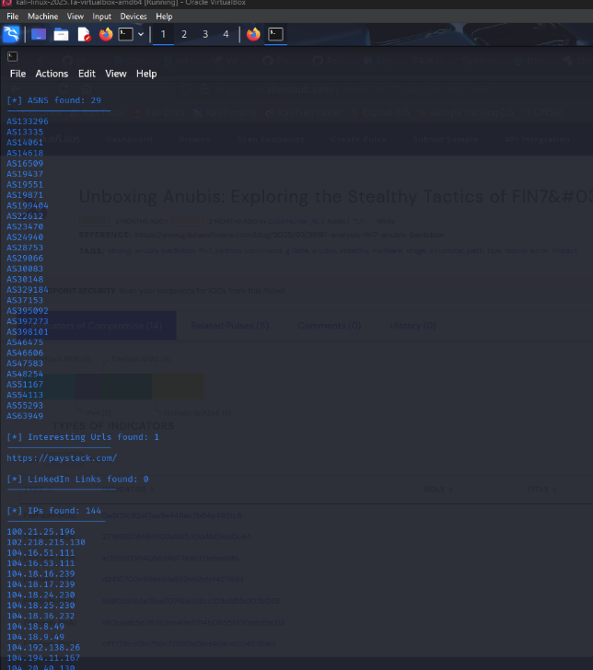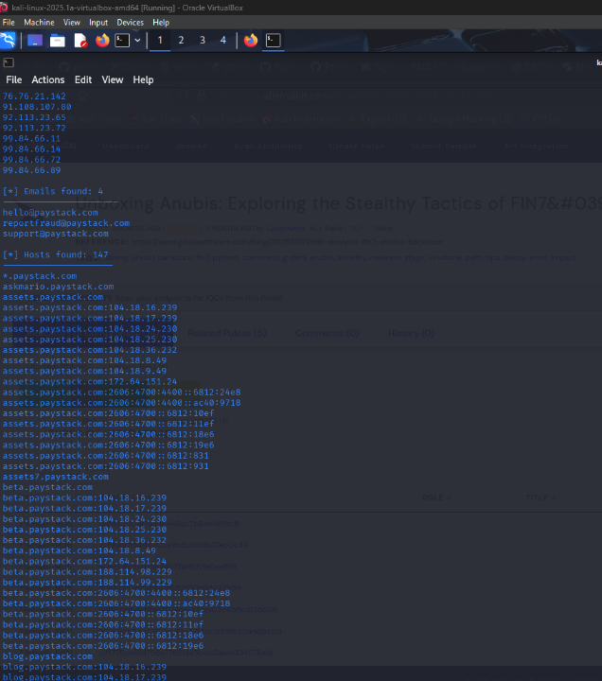
Image shows the findings of theHarvester

Google Dockings
- Purpose: Was used to uncover unintentionally exposed documents and developer resources related to Raptack. The goal is to discover sensitive files indexed by search engines, which could include internal documents, codes, or executive information that way aid in reconnaissance or future attacks.
- Findings: Through advance search operators, I was able to locate a publicly accessible PAIA (Promotion of Access to Information Act) PDF document. This document contained contact details of top-level executives, including the CEO’s direct phone number, email, address, along with similar information for the company’s information officer and Deputy officer. Additionally, I found an exposed PHP file potentially related to the backend web service or sandbox’s APIs. The search also led to discovery of Raptack’s open-source developer sandbox via github, including tools and resources made available for API testing and developer integration.
- Implications: Exposure of such a highly detailed PAIA file poses a serious risk to the organization. With direct contact information of executives publicly available, attackers can easily orchestrate whaling attacks (form of Phishing that target top level individuals). Such information can also facilitate an impersonation attacks and more convincing social engineering attempts. The PHP file, depending on its content, might expose endpoints, or API structure which could be leveraged for vulnerability probing or unauthorized access. Furthermore, the open-source sandbox provides a detailed view of how Raptack’s API work, potentially allowing attackers to stimulate legitimate interactions or fine-tune credential harvesting campaigns. Altogether these findings demonstrate how free accessible search result can expose an organization inner workings and weaken its external security posture.

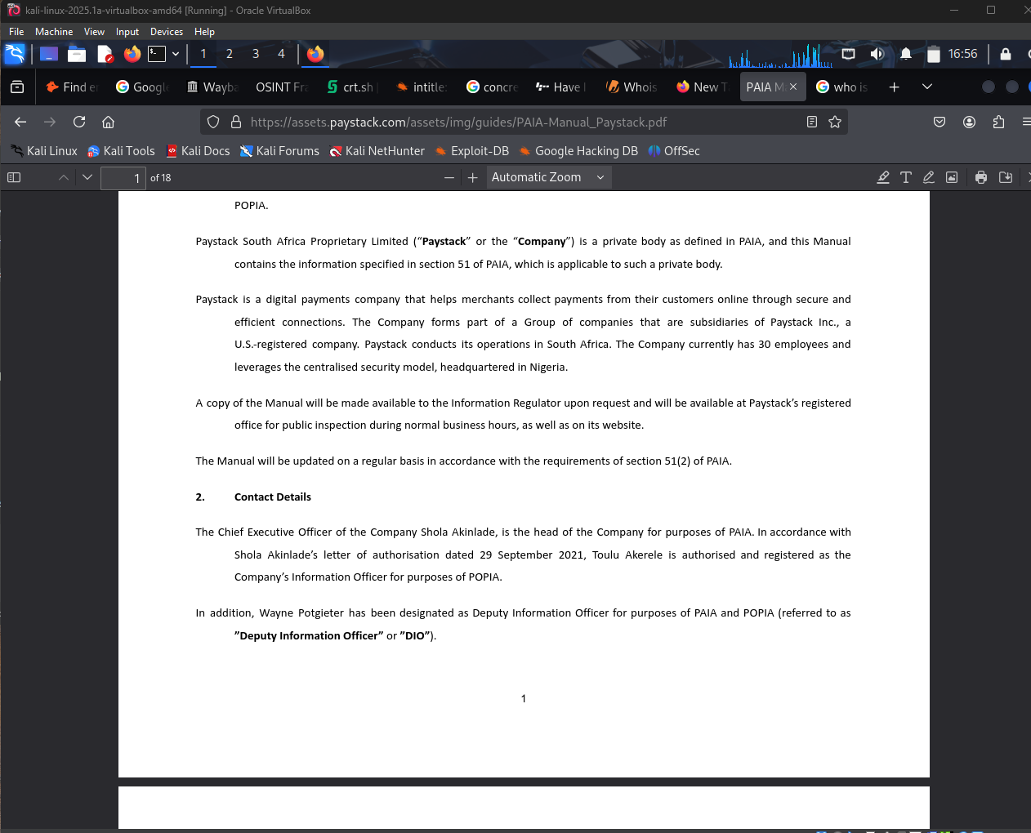
Image shows the pdf findings with google dockings

Crt.sh
- Purpose: Crt.sh is certificate transparency log search tool that allows for querying SSL/TLS certificate issued for domain. It helps uncover subdomains, domains relationships, and the certificate management practices of the organization, which are vital during reconnaissance and infrastructure mapping.
- Findings: A variety of active and historical SSL certificates were discovered. These included certificates for key Rapstack subdomains such as dashboard.paystack.com, checkout.paystack.com, secure.paystack.com, support.paystack.com, status.paystack.com, and sandbox.paystack.com. This were specific to service-oriented domains issuers varied across Amazon, DigiCert, Google Trust Services, covering a period of 2016 to 2025. This level of detail reveals not only current endpoints but also deprecated or legacy domains that were once in use.
- Implications: The indicate that Raptack digital infrastructure span across several domains, which some of maybe legacy or underused. This increases the potential attack surface, particularly if older domain is no longer maintained or secured to modern standards. Furthermore, the inclusion of third-party domains suggests external dependencies, which could increase supply chain risk. A threat actor could use this data to perform targeted attack on specific Raptack services, craft phishing domains that look legitimate, or probe older, less secured infrastructure for vulnerabilities.
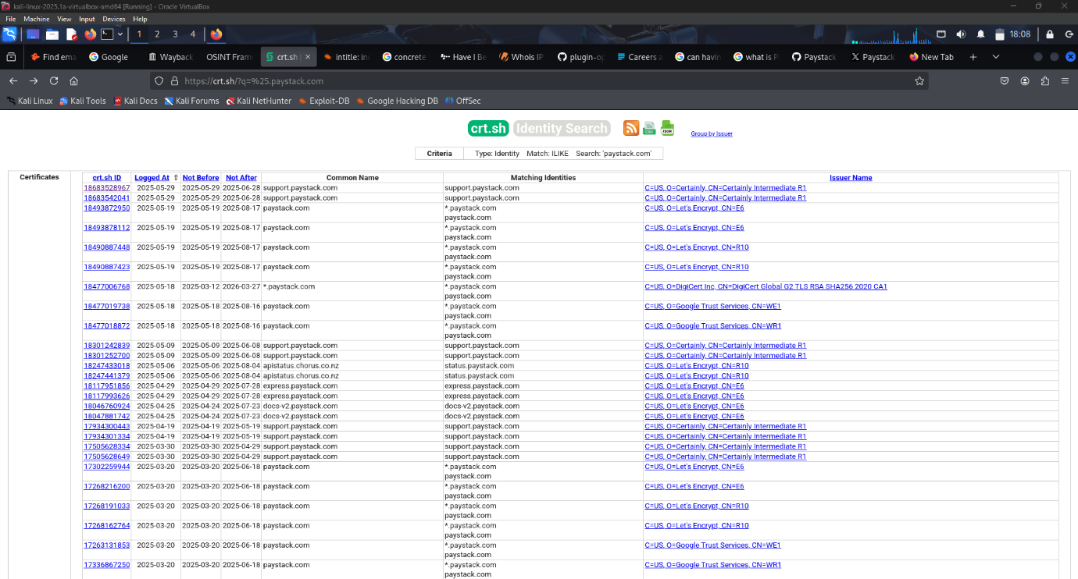
Image shows the Crt.sh findings on Raptack

Whois LookUp
- Purpose: It’s used in reconnaissance to obtain publicly available registration details of domain, including information about its creation, expiration, register, and administrative contacts. This helps to understand domain ownership, registration patterns, and possible operational timelines.
- Findings: The domain was registered on July 28, 2011 and is set to expire on July 28, 2026. The domain is registered with Amazon Registrar, inc, and uses Cloudflare’s as DNS servers. The registration is privacy protected with the registration listed as acting on behalf of Raptack owner. Contact information includes and abuse email and phone number associated with the registrar. The domain has active prohibitions on delete, transfer, and update operations, indicating a secured configuration.
- Implications: The domain’s long-term registration and reputable service providers like Amazon and Cloudflare suggest operational maturity and security-conscious infrastructure. However, with domain privacy protection, attackers may still attempt social engineering using the registrar contact details as pretext. Additionally, knowing about the domains age and expiry details allows threat actors to predict or plan around DNS renewal periods or exploit expired domains in wider attack chain. Also, impersonation risk exists if similar domain names are purchased by attackers to conduct phishing or brand spoofing.

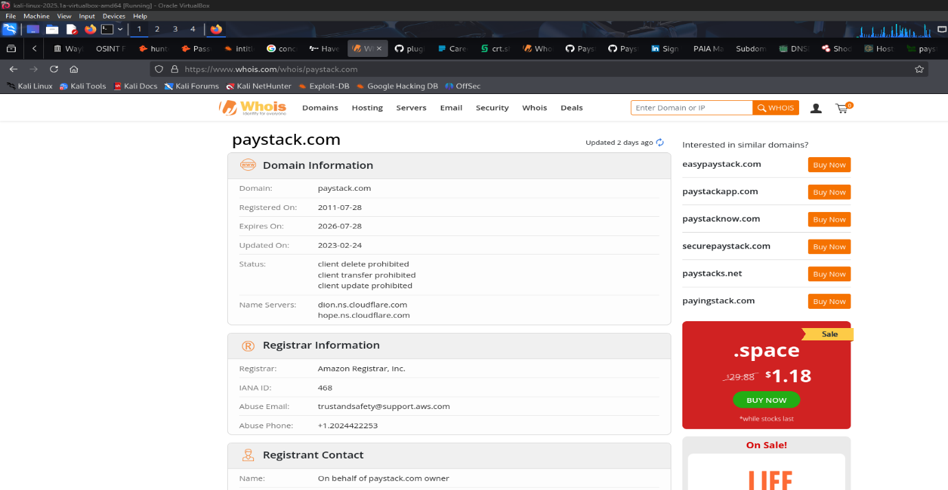
Image shows the Domain registrations information

Linkedin
- Purpose: It’s used to Raptack’s internal hiring trends, technology stack, and identity potential human target for social engineering efforts.
- Findings: A recent linkedin job listing for a Backend Engineer, reveals a preference for candidates skilled in JavaScript, Python, and TypeScript, with hands on experience in a web framework like React and Vue.js. The job posting also indicates usage of AWS, Docker, and Kubernetes for infrastructure management, as well as CI/CD pipelines for software delivery. The role emphasizes secure development practices, performance optimization and familiarity with software architecture, RESTful APIs, and distributed systems.
- Implications: The job post provides valuable insights into the backend infrastructure, and development practices, offering a glimpse into their tech stack and DevOps environment. It also confirms their alignment with secure coding standards and possibly regulatory compliance requirements, such as PCI-DSS. From a threat intelligence standpoint, this information can guide the profiling of potential technical staff as high value target for spear phishing, particularly those involved in hiring, or system configuration, thereby raising concerns about supply chains compromise or insider exploitation.
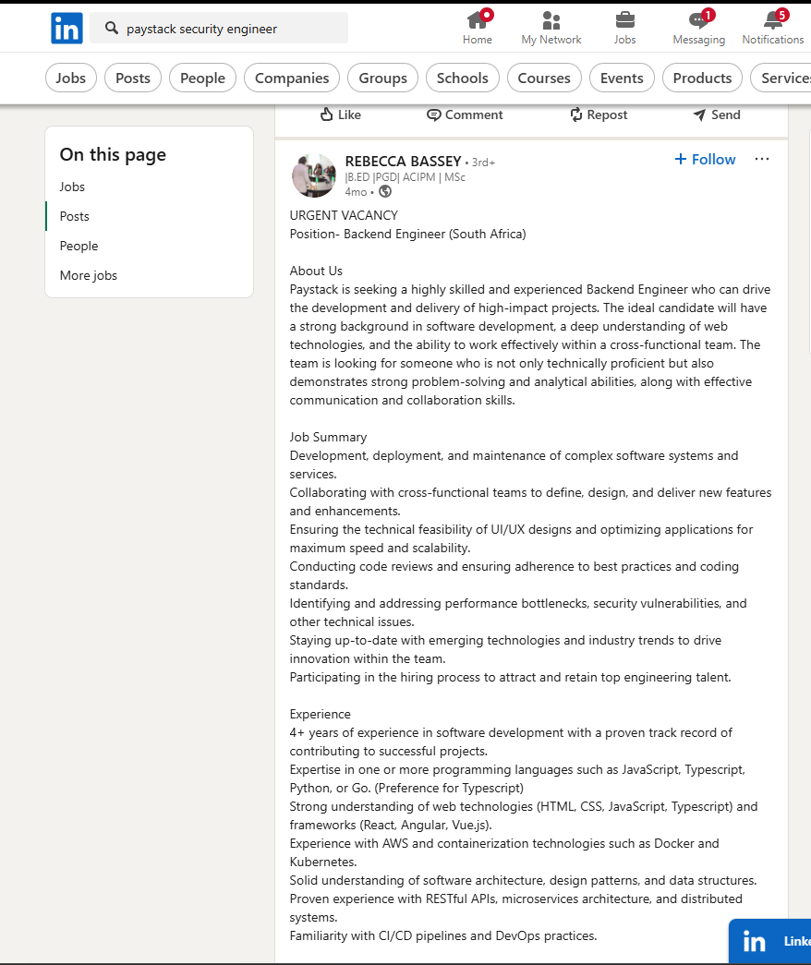
Linkedin Job posting

Censys.io
- Purpose: To perform reconnaissance on Raptack’s infrastructure, with the goal of identifying exposed services, security controls, potential misconfigurations that could in threat modelling or vulnerability assessment.
- Findings: Revealed multiple IP addresses associated with Raptack’s hosted on AWS and Cloudflare, showing the use of load balancers Web application firewalls (WAF), which point to a security aware infrastructure. However, several ports were found to be open including 21 (FTP), 80 (HTTP), and 433(HTTPS), The presence of port 21 is noteworthy, as insecure or actively exposed FTP services may introduce risk such as credential sniffing, anonymous access, or brute force attacks. Additionally open ports on Cloudflare 2082, 2083, and 2095 indicate in active services that warrant closer inspection. The presence of front-end libraries like Bootstraps and Raphael suggests reliance on known web technologies which could potentially expose the environments to version specific areas for vulnerability if not properly managed.
- Implications: The combination of cloud hosted services, security focused configurations and open ports paints a picture of moderately hardened infrastructure. However, the exposed FTP services significantly increase the attack surface and could be exploited if left unpatched or improperly secured. The use of popular web libraries also introduces a risk of exploitation through know CVEs if outdated version is in use. These insights are valuable for mapping out external threats landscape identifying specific areas for vulnerability scanning or exploit simulations.
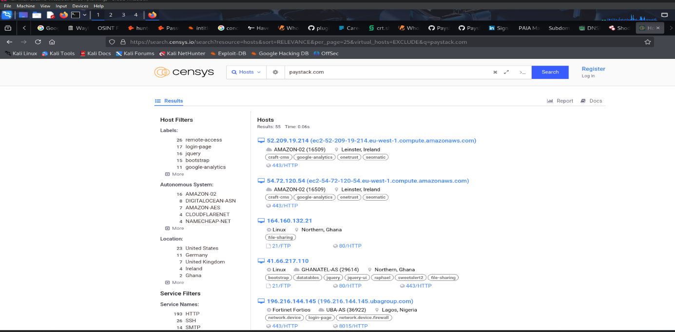
Image show’s open ports and other vital information from Censys.io

Recommended Intelligence Sharing Organization
To enhance threat detection, collaboration, and response, Raptack is advice to join these professional cybersecurity communities:
- FS-ISAC (Financial Services information Sharing and Analysis Center)
- MAD (MITRE ATT&CK Defender)
- CTA (Cyber Threat Alliance)
- AUCSEG (African Union Cybersecurity Expert Group)
- FIRST (Forum of Incident Response and Security Teams)

SECURITY RISK ASSESSMENT
Security risk assessment is the process of identifying, analyzing, and evaluating risk that could potentially affect the confidentiality, integrity, availability of Raptack information system and data.
Threat Classification Based on Extracted Information
Targeted Phishing & Email Attacks
Exposed emails and naming patterns can be used for phishing, especially if attackers known names, roles, and job posting on linkedin or public reports.

Reconnaissance for Infrastructure Attacks
Knowing IP addresses, subdomains, and SSL certificate gives attackers a map a Raptack’s digital infrastructure to plan more direct attacks like web exploitation or brute-forcing login portals.

Brand Damage & Trust Loss
If threat actors impersonate Raptack (e,g spoofing emails by using discovered addresses), it can lead to fraud, loss of customer trust, or regulatory breaches.

Credential Reuse Attack
Public email addresses, especially when leaked in data breaches found on platforms like the harvester can lead to credential stuffing if employee reuse password.

Categories | Information founds | Threat | Potential Risk | Vulnerabilities | Mitigations
Emails | 4 emails patterns found via theHarvester. | Email harvesting, spoofing, phishing | Social engineering, business email compromise (BEC), Impersonation. | Use of predictable email format patterns, public exposure of emails. | Implement SPF, DKIM, DMARC, also train staff on phishing awareness.
Public IPs | Public IPs found via theHarvester and Censys | IPs scanning, DDoS, lateral Probing Which can disrupt services by flooding with traffic, Insider threat. | Direct exploitation, DOS from known addresses | Static IPs publicly available and traceable. | Apply WAF (Web Application Firewall) rules. Use geo-fencing. Rate-limit request.
Hosts | 147 total hosts were found. | Asset’s sprawl, misconfigured environments. | Compromise via stale or hidden services. | Dev/test or forgotten production systems unpatched | Maintain asset inventory. Scan hosts regularly using tools like Nmap, Shodan, or Censys. Enforce patch SLAs. Also remove unused or test environments from public exposure.
ASN | 29 ASN across cloud were found (e.g., AN133296, AS13335, AS19437, etc.) | BGP hijack, full-range ASN scanning for vulnerable hosts Exposure of internal infrastructure if IP block is known Targeting by threat actors based on ASN reputation (e.g., government, banking sector ASNs) | Undetected traffic rerouting or downtime attacks. Denial of service, man in the middle attacks as the ISP/network level. | Malicious actors can attempt to advertise routes that belong to ASN. May lead to traffic redirection, surveillance, or blackholing of services. Fragmented hosting structure hard to monitor holistically | Enable RPKI, Monitor ASN to IP mapping. Use multi layered monitoring tools.
URL | 1 interesting URL was found (https://raptack.com) used as portal entry | Cloning, phishing, domain impersonation. Spice may gather information from exposed interface. | Attack surface mapping, this helps attackers to know where to target with being able to carry out customer phishing, credential harvesting. | URL easily spoofed for social engineering, which can lead to login brute force. Sensitive data exposure because the query string may contain password or user or user information. | Register typo variants, monitor phishing kits enforce HSTS and DNSSEC. And make sure to validate permission.

Threat Actors and Relevance to Fintech Sector
The following threat actors have been active recently and possess tactics and techniques that align with the types of information discovered in this passive intelligence report. Given that target organization is a fintech institution, the actors below represent relevant and realistic threats:

1. Scattered Spider
- Overview: This is an advanced social engineering and SIM swapping group that targets large organizations, including fintech by impersonating IT staff or using multi factor authentication fatigue techniques.
- TTPs: SIMs Swapping, MFA fatigue, Okta bypass, PowerShell, remote desktop abuse.
- Notable incident: In 2023, they targeted MGM resorts, compromising internal systems and causing major disruptions. They are also associated with identity-based breaches at Okta customers, many of which are FinTech services.
2. FIN7(a.k.a Carbanak Group)
- Overview: A financially motivated group known for targeting banks, payment processors, and POS malware to gain financial access.
- TTPs: Spear phishing, backdoors (Carbanak, Griffion), credential theft.
- Notable incident: Between 2015 – 2020, FIN7 stole over $1 billion from banks and FinTech Related services globally.
3. TA505(a.k.a Evil Corp)
- Overview: A financially driven actor behind Dridex and locky malware, known for targeting banks and financial organizations with large scale spamming campaigns.\
- TTPs: Spam phishing, use customs ransomware, exploit kits, credential theft.
- Notable incident: Delivered clop ransomware and Dridex trojan to fintech platforming Europe and Asia.
4. Lazarus Group (North Korea)
- Overview: State sponsored actor linked North Korea, known for high profile heists including the Bangladesh Bank Hack and recent Cryptocurrency exchange hacks.
- TTPs: Spear phishing, Zero-day exploits, remote access tools.
- Notable incident: 2016 Bangladesh bank swift breach ($81 million theft), 2022 ronin network (Axie Infinity) hack ($625 million).
5. Conti Ransomware Group
- Overview: Conti is a top tier ransomware as a service group. Known for attacking corporate networks and extorting large sum.
- TTPs: Initial access via phishing, lateral movement with RDP, data exfiltration, and double extortion.
- Notable Incident: Targeted Costa Rica government, health care and banking institution before dissolving in 2022.

These attacks have shifted global cybersecurity policy has proven that FinTech organization are high value targets.

Most Dangerous Threat actor to FinTech (Raptack)
FIN7 (a.k.a. Carbanak Group)
FIN7 is one of the most prolific and financially motivated cybercriminal groups in the world. Known for breaching banks, POS systems, and payment processors, this group presents a high-level threat to digital financial platforms such as Raptack, which operates in the heart of Africa’s rapidly growing FinTech ecosystem.

1. Tailored Targeting of Financial and Payment Systems
FIN7 doesn’t cast a wide net they select their victims carefully. Their focus of payments infrastructures, online transactions APIs, and customer data handing platforms places Raptack squarely in their threat landscape. This is further validated by Raptack use of APIs like api.raptack.com and payment endpoint, their direct integration with businesses across sectors, processing sensitive financial PII data. They also have publicly visible job listings showing roles related to PCI-DSS compliance, Docker, Kubernetes, and AWS, which can hint at internal architecture to attackers. All these details, found make Raptack a prime target for an actor like FIN7.

2. Complex Attacks Designed for Cautious and Persistence
FIN7 is not an opportunistic. They infiltrate environments using carefully engineered spear phishing emails followed by advanced malware deployment and custom backdoors. Their know behaviours includes, deploying weaponized documents via malicious emails attachments (T566.001), escalate privileges, establish persistent remote access, perform command and control (T1071) communications over HTTPs to blend in with normal traffic. These tactics allows FIN7 to remain undetected while manipulating systems from within that would be catastrophic for a platform like Raptack that handles real time payment transactions and merchant data.

3. Deep Reconnaissance and Infrastructure Awareness
FIN7 often uses passive intelligence before launching their attacks similar to the OSINT findings that I carried out in this project, they profile emails, job vacancies, GitHub projects, exposed subdomains and even open ports and ASN/host information. This mirrors their real-world tactics of profiling digital surfaces to identify initial access vectors, then carefully crafting payloads and phishing campaigns accordingly.

FIN7 is a major threat to Raptack or any major FinTech organization due to their focus on core banking infrastructure. Raptack operates at the transactions layer e-commerce and financial services which is FIN7 favourite layer to exploit. They are known to manipulate POS like infrastructure and Raptack severs thousands of businesses in that space. Also, they leverage custom tools and malware, which can evade traditional antivirus making defence difficult for mid-level FinTech Companies.
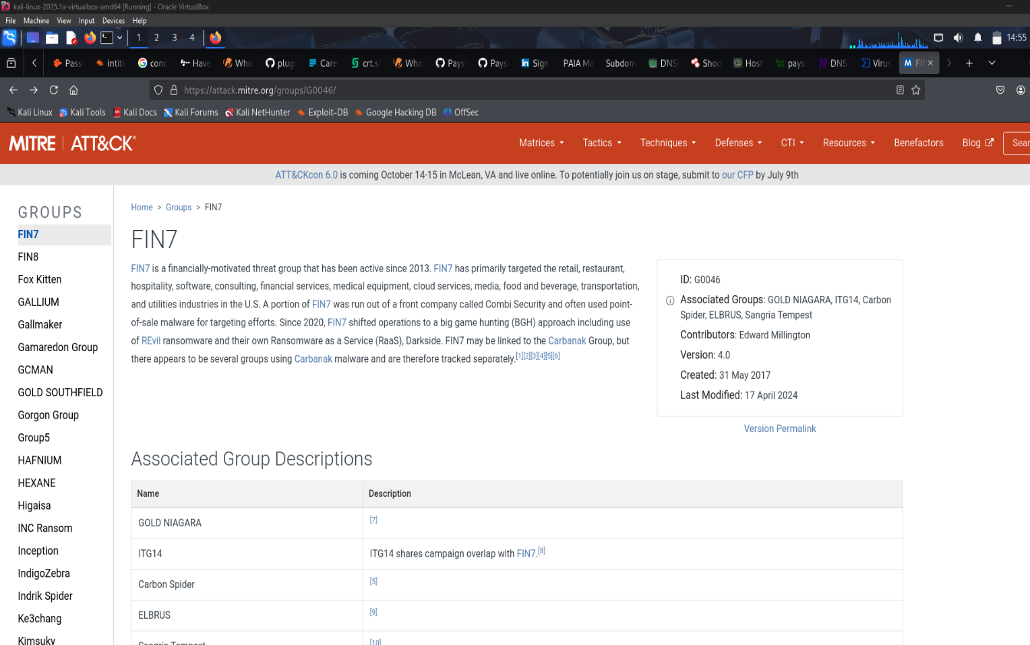
Image shows FIN7 on the MITRE ATT&CK framework

FIN7 MITRE ATT&CK MAPPING
Tactic | Technique ID | Technique Name | Description
Initial Access | T1566.001 | Spear phishing attachment | Sending malware through targeted emails to gain access to finance/ admin staff.
Execution | T1059 | Command and scripting interpreter | Payload execution through PowerShell of windows cmd.
Persistence | T1547.001 | Registry run keys/ start up folders | Ensure malware restart with system boot.
Credential Access | T1003 | OS credential dumping | Harvest user’s credentials from memory.
Lateral movement | T1021.001 | Remote desktop protocol (RDP) | Moving laterally inside network using RDP.
Command and control | T1071.001 | Web protocols | Converts control over HTTPs traffic
Defence Evasion | T1027 | Obfuscated files or information | Encoding scripts to bypass AV/firewall filters.
Impact | T1486 | Data encrypted for impact | Encrypts sensitive data, used for extortion in advanced campaigns.

Summary
FIN7 playbook aligns very closely with Raptack’s infrastructure and business model. Their use of phishing, custom malware, and POS focused exploits presents a major risk, especially in environments rich in customer payment data and merchant APIs. Given the findings in carried out in the threat intelligence report including exposed subdomains, job roles revealing tech stack, GitHub repository, and open ports Raptack must consider FIN7 a high priority adversary.

Recommendation
- Train staff to recognize phishing emails, employees should know how to spot suspicious emails to avoid falling for targeted attacks.
- Use Strong Passwords with Multi-Factor Authentication, by enforcing secure passwords and require MFA for all user and admin accounts.
- Shut down or secure any exposed ports like FTP (port 21) to reduce attack surfaces.
- Use web application firewalls (WAF) and rate-limiting on public APIs like
- Regularly audit Raptack’s GitHub projects for accidentally leaked API keys or sensitive files.
- Use threat intelligence tools to stay informed about attackers like FIN7 targeting the FinTech industry.

Reference

- AlienVault OTX Threat Intelligence https://otx.alienvault.com
- theHarvester Used to gather emails, subdomains, IPs, and ASNs.
Tool link: https://github.com/laramies/theHarvester
- Google Dorking Used to find PAIA files, exposed code, and open directories.
Guide: https://www.exploit-db.com/google-hacking-database

- crt.sh (Certificate Search) To discover Raptack’s subdomains via SSL certificates.
Website: https://crt.sh
- SecurityTrails For DNS history, IP, ASN, and subdomain exploration.
Website: https://securitytrails.com
- DNSDumpster Used to visualize subdomain and DNS mapping.
Website: https://dnsdumpster.com
- GitHub Search To find Raptack’s open-source tools and possible code exposures.
Website: https://github.com
- LinkedIn For gathering job postings and internal tech stack exposure.
Website: https://www.linkedin.com
- Censys.io For discovering open ports and cloud infrastructure details.
Website: https://search.censys.io

- Whois Lookup Used to identify registrant info of Raptack’s domain.
Tool: https://who.is
- VirusTotal For checking malware indicators related to domains and IPs.
Website: https://www.virustotal.com
- Wayback Machine To view historical versions of Raptack’s website.
Website: https://archive.org/web/
- MITRE ATT&CK Framework https://attack.mitre.org

Appendix: Screenshots and Visual Evidence
